Reg ID - GO_STP_6834

Day 10:

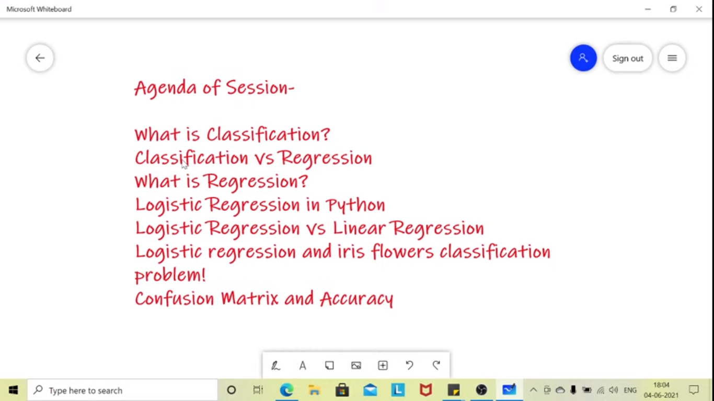

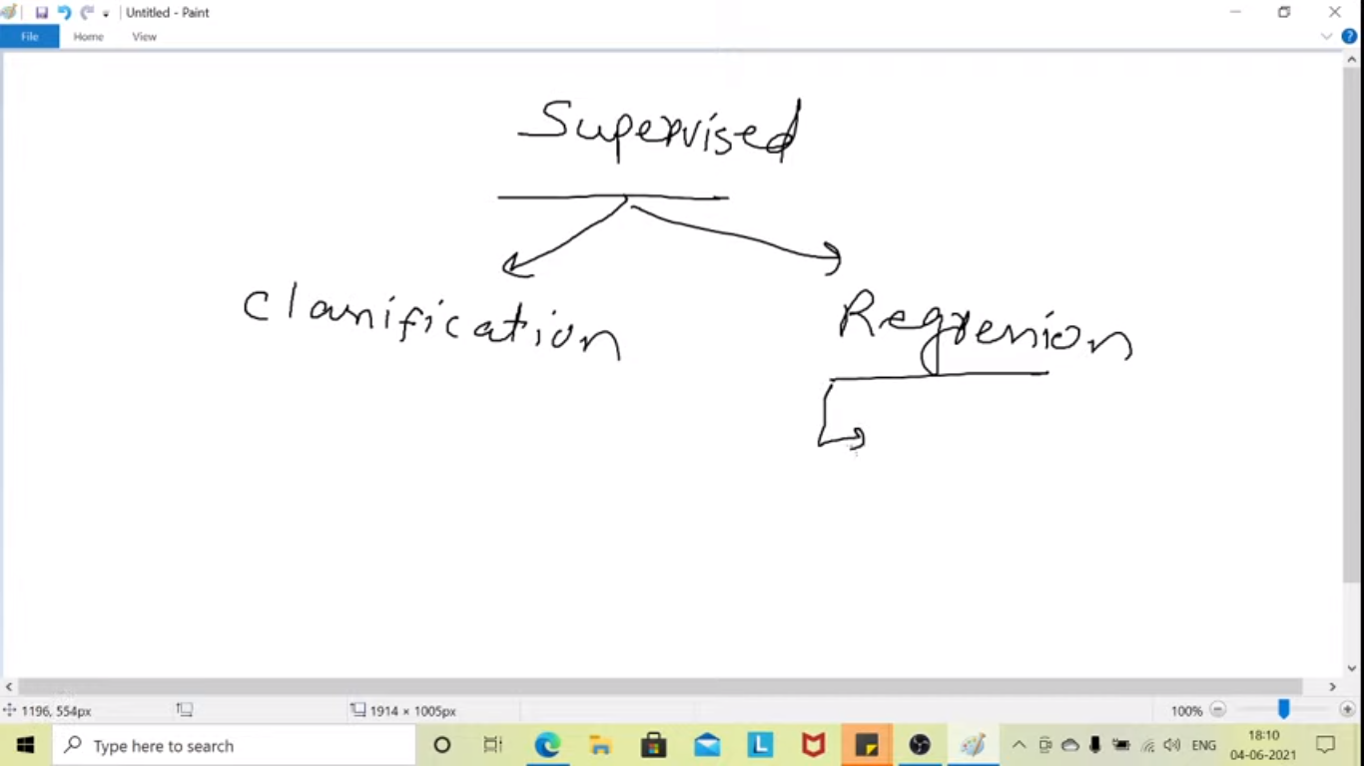

Regression: Predicting continuous value

Classification: Predicting Classes or categorical

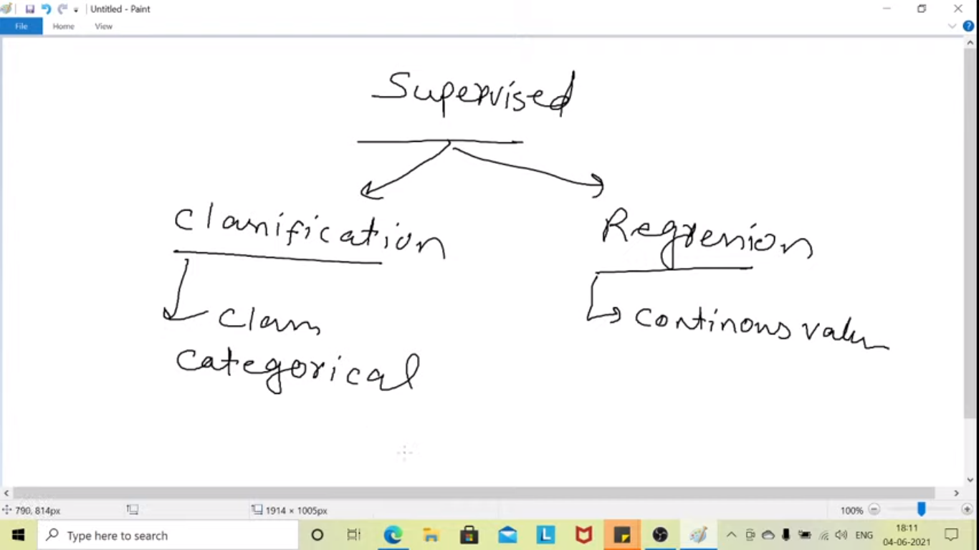

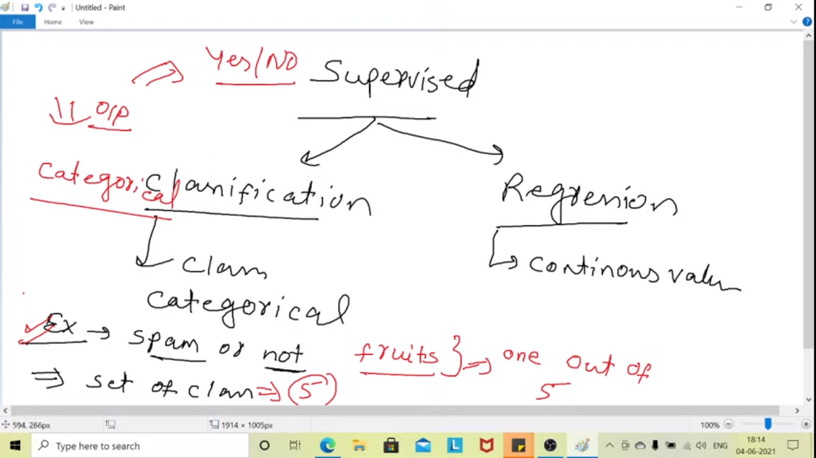

Binary classification – Two output – like yes or no, spam or not spam

Output or response var – Categorical

Multi-classification – can have many outputs

Regression- Predicting technique for predicting continuous quantity. Will have infinite no of possibilities

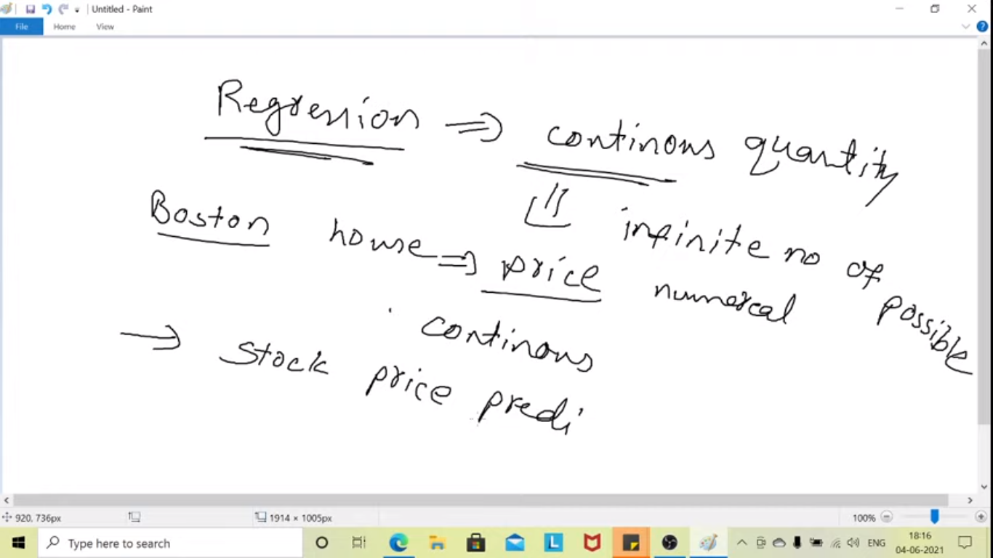

Under classification the no of possibilities is definite.

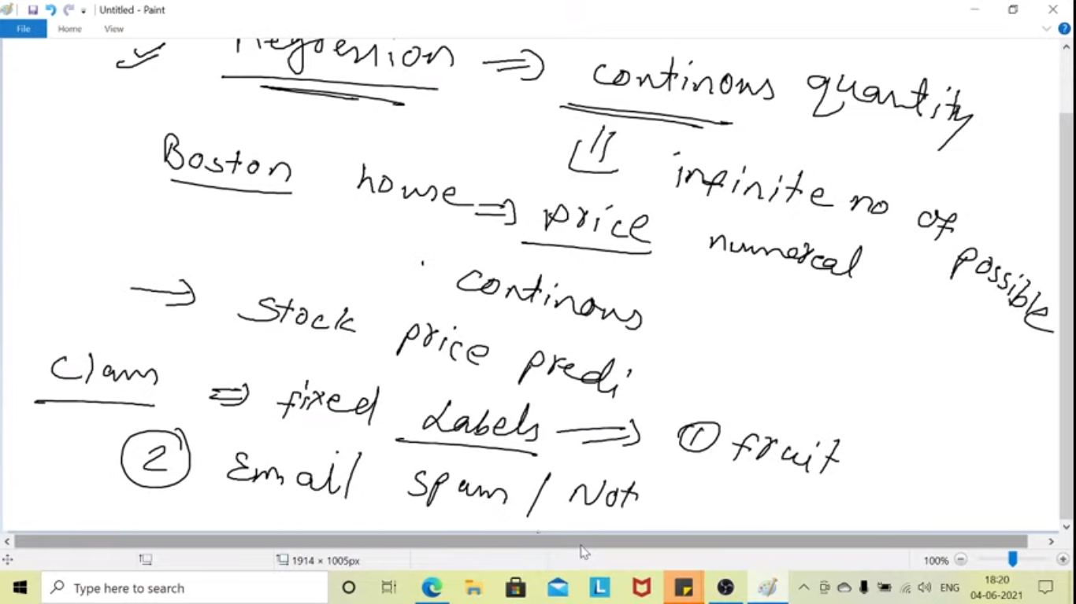

**Logistic Regression: technique to analyze the data set. Predict categorical variable.**

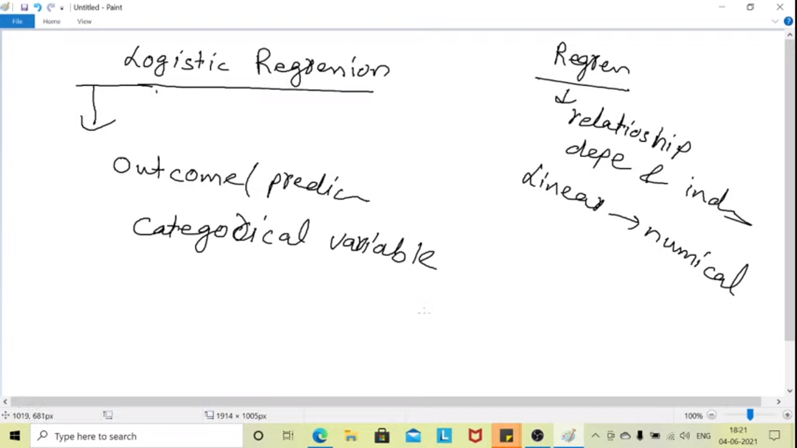

**We use sigmoid function to predict the categorical var**

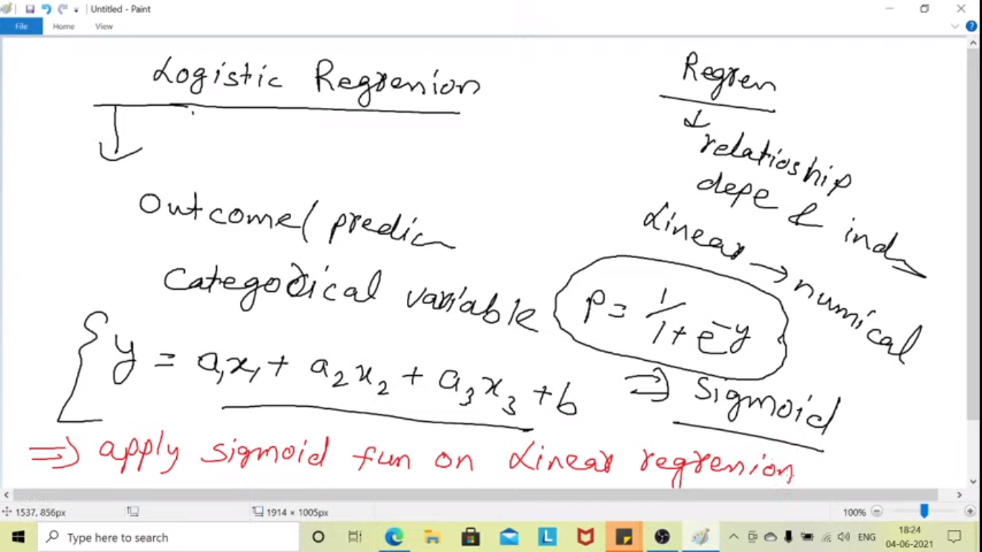

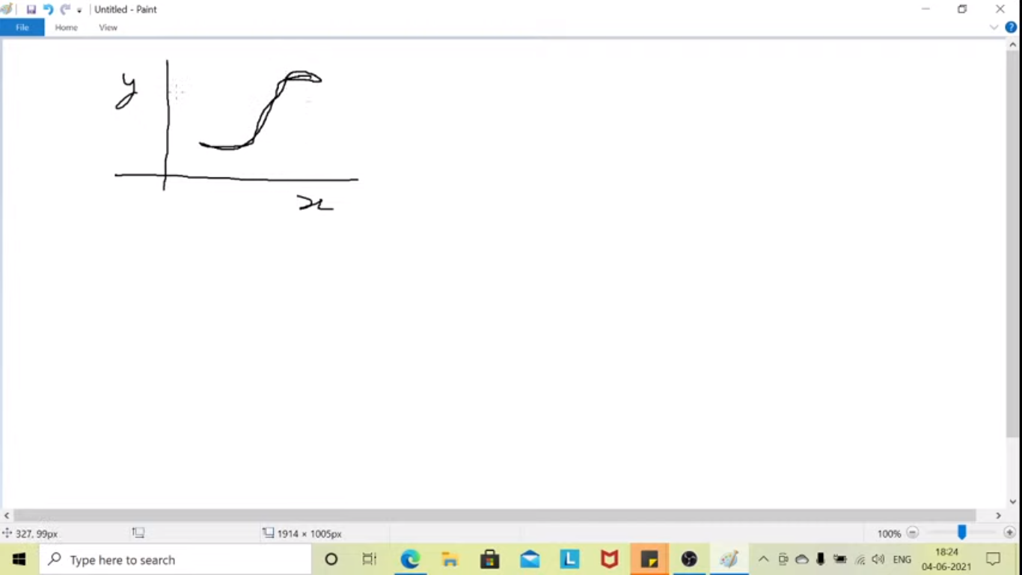

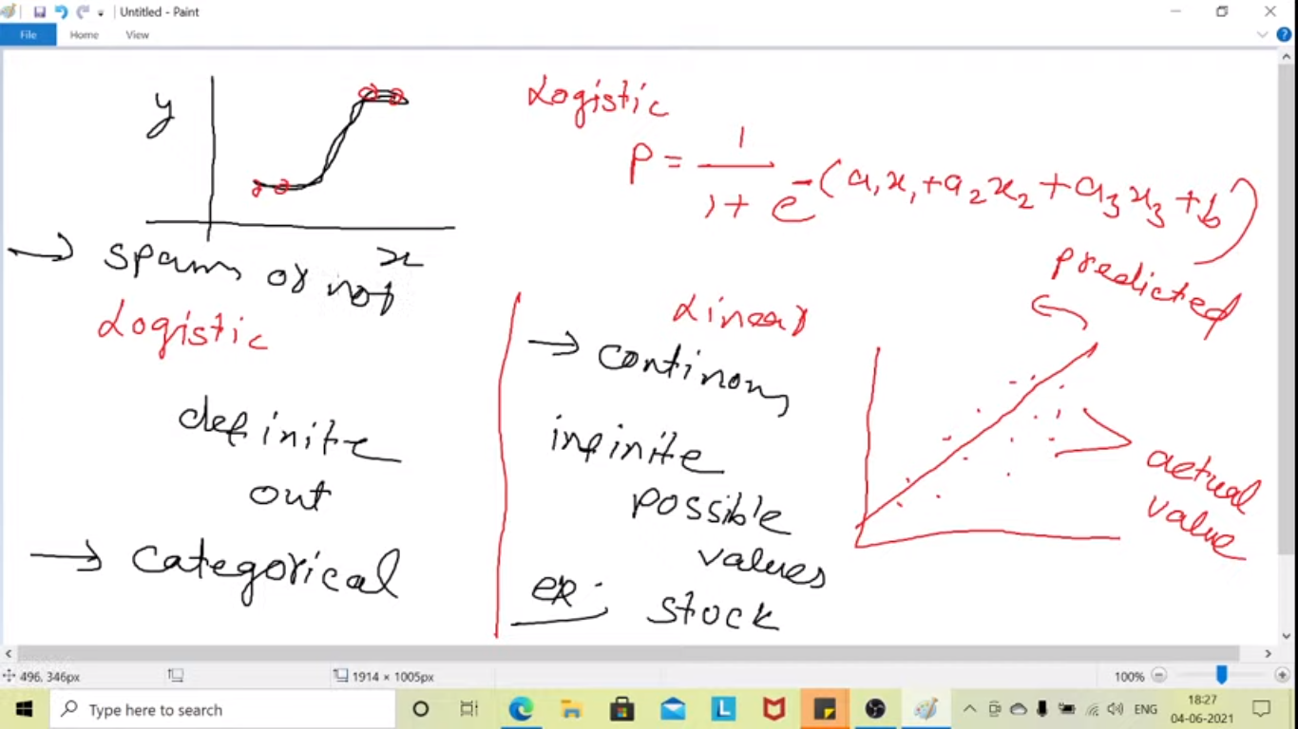

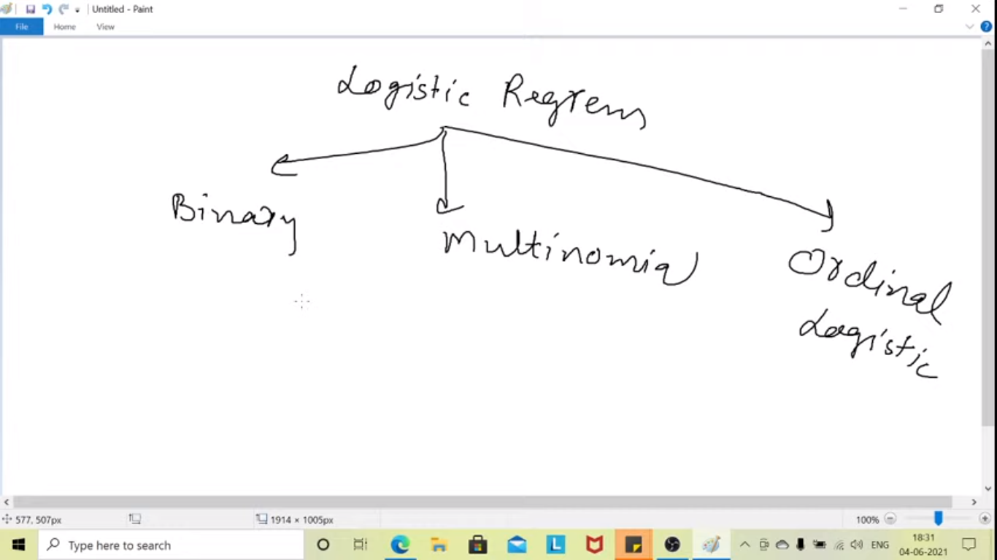

**Binary – Only 2 classes -0 or 1**

**Multinomial – more than 2 classes**

**Ordinal – data having sequence, like movie rating, where order of the output is significant**

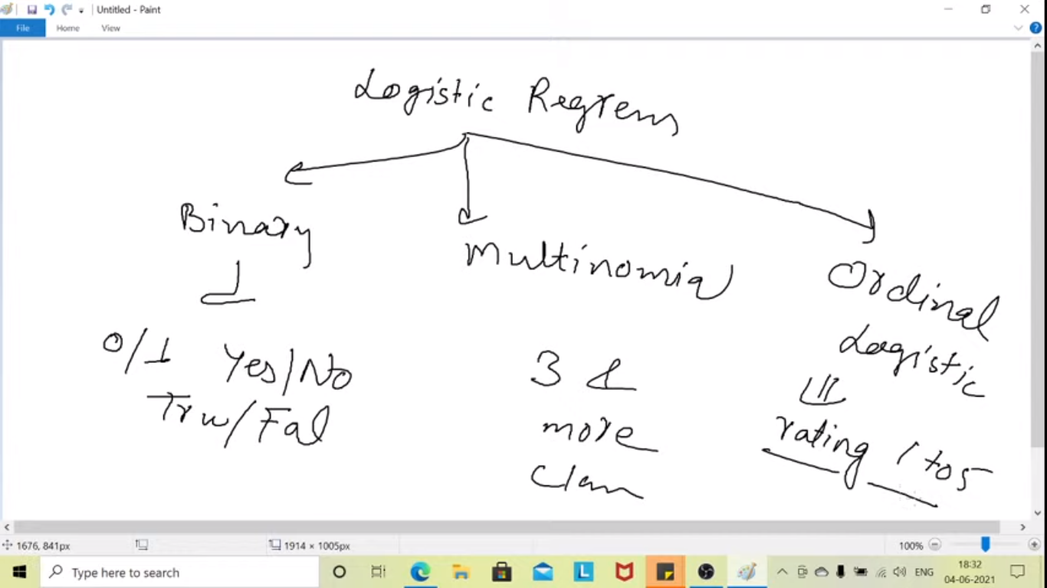

**Problem :**

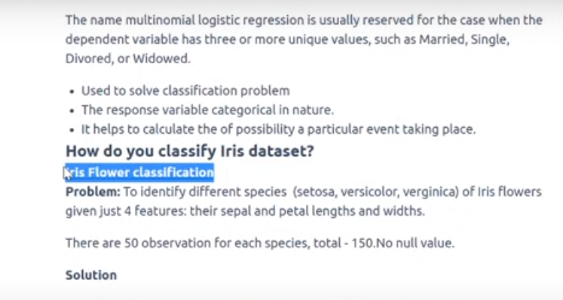

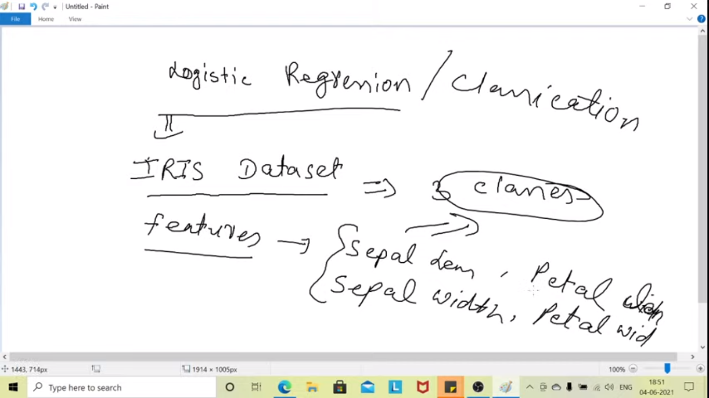

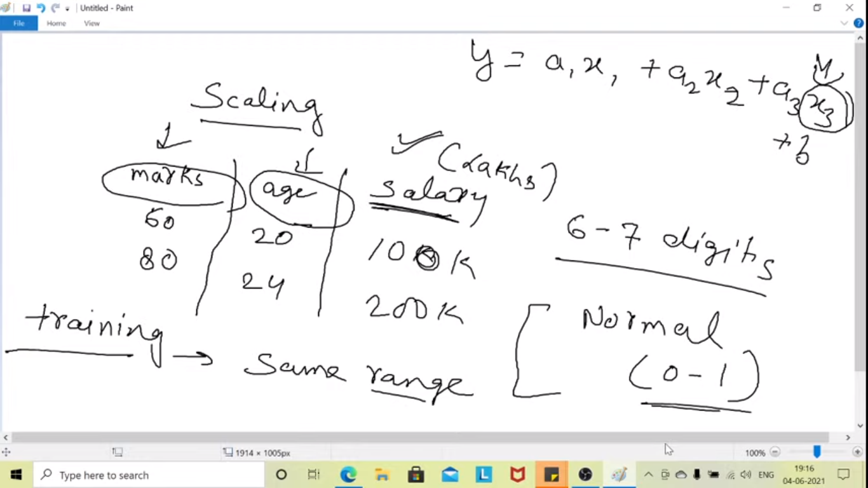

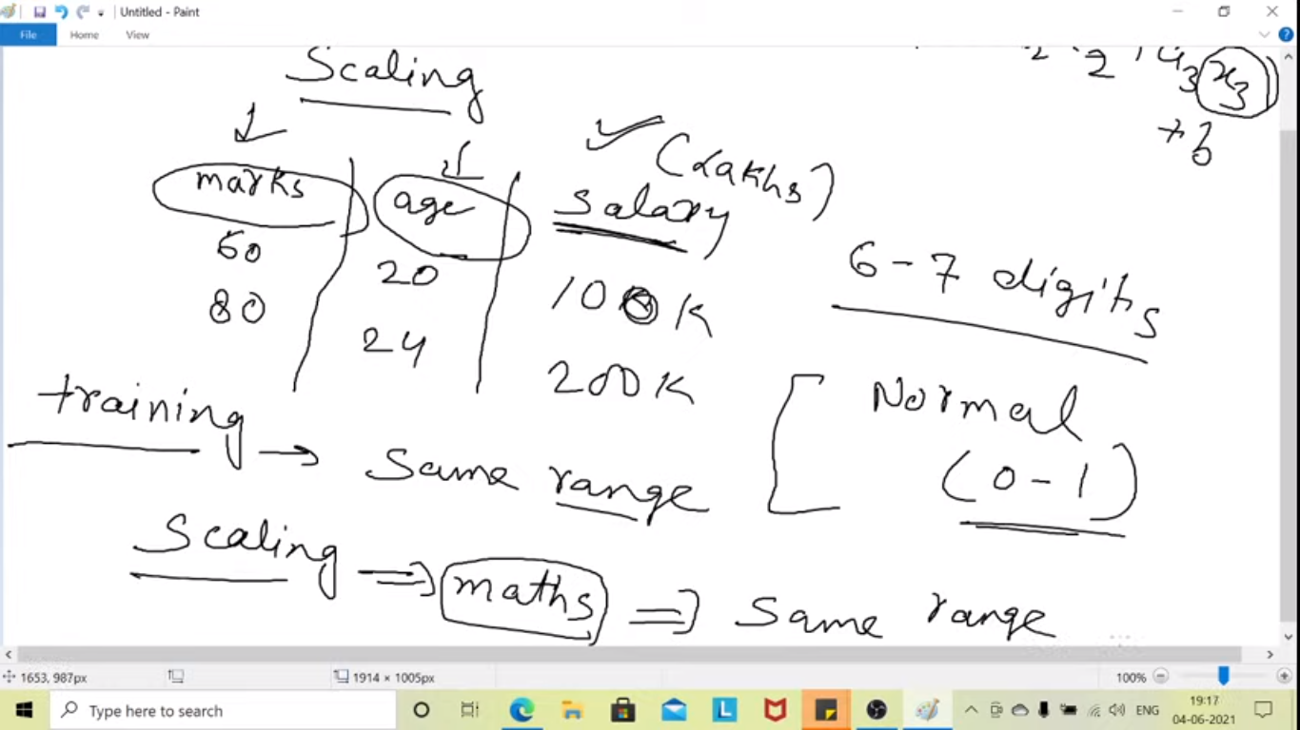

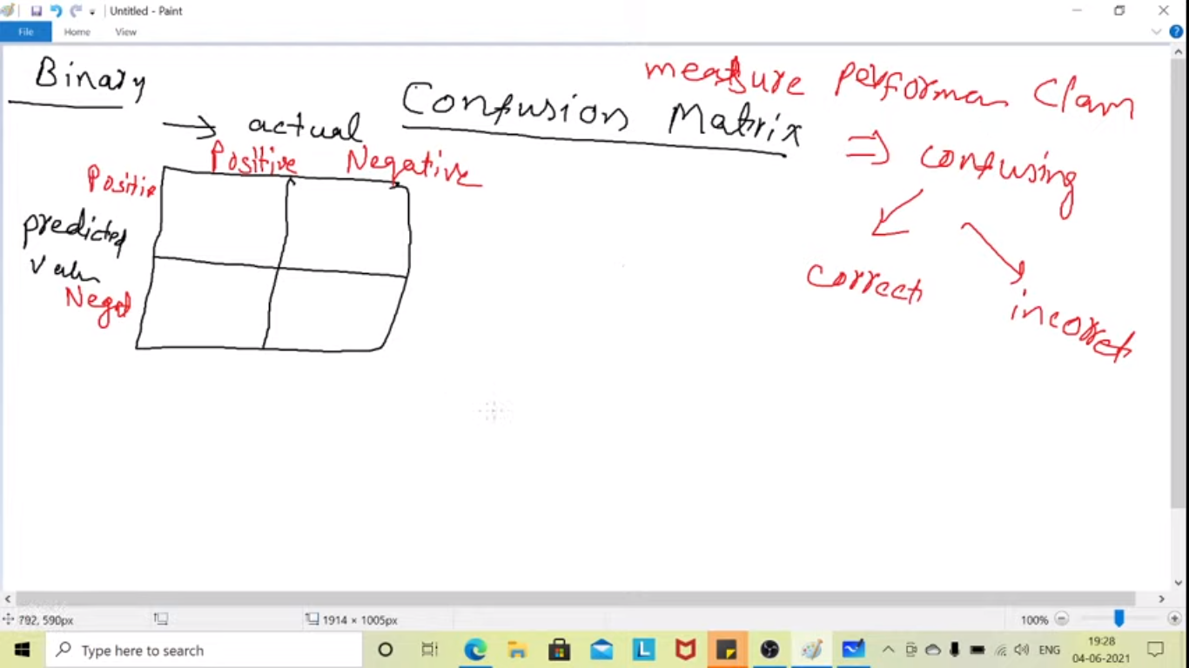

**To find the performance of classification we go for confusion matrix**

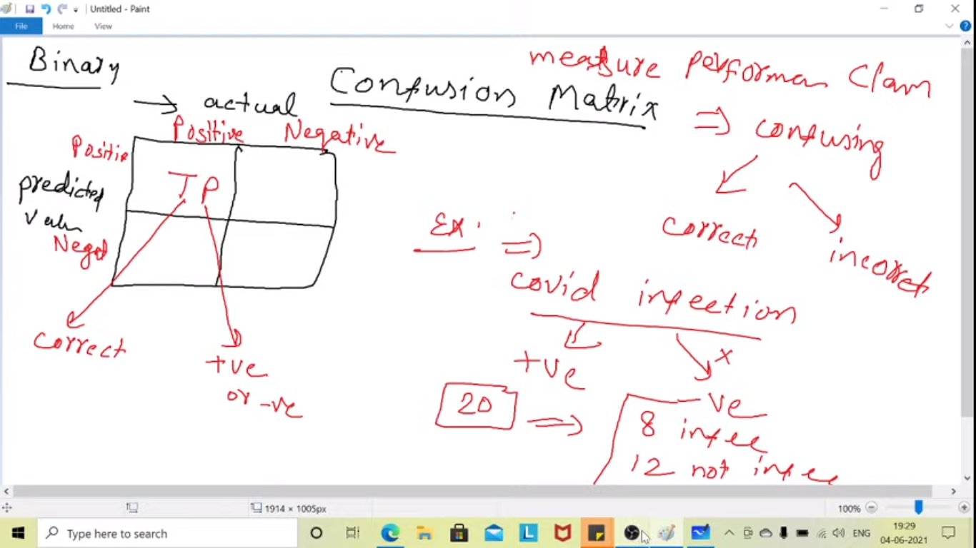

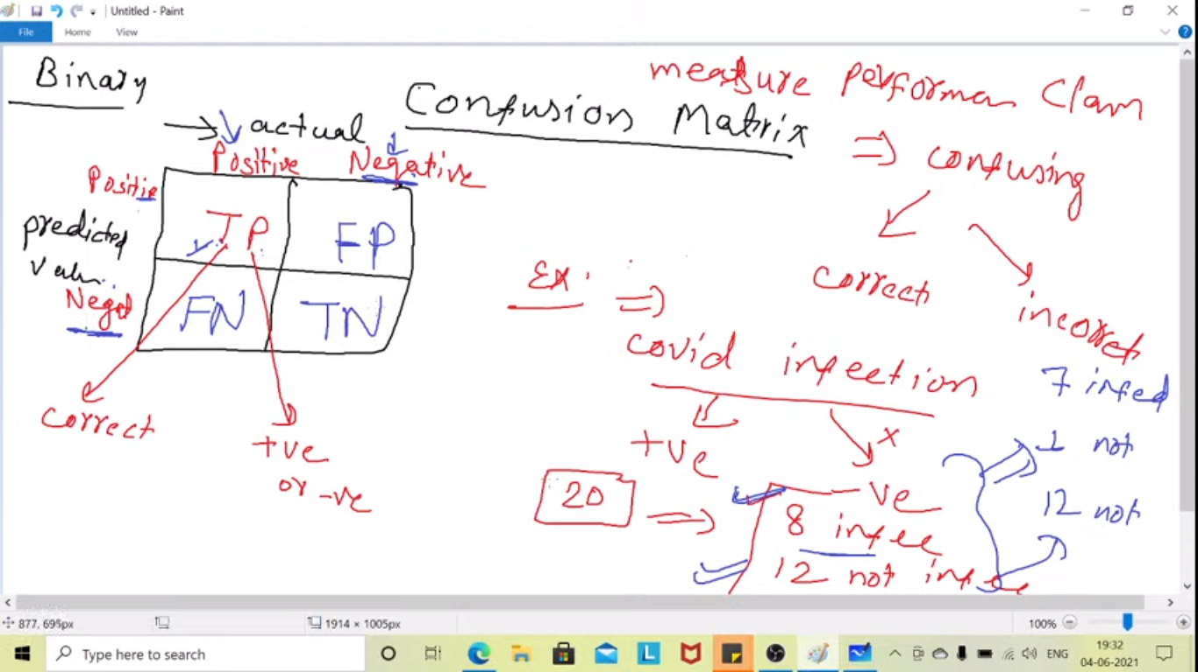

**To tell how accurate the model is predicting**

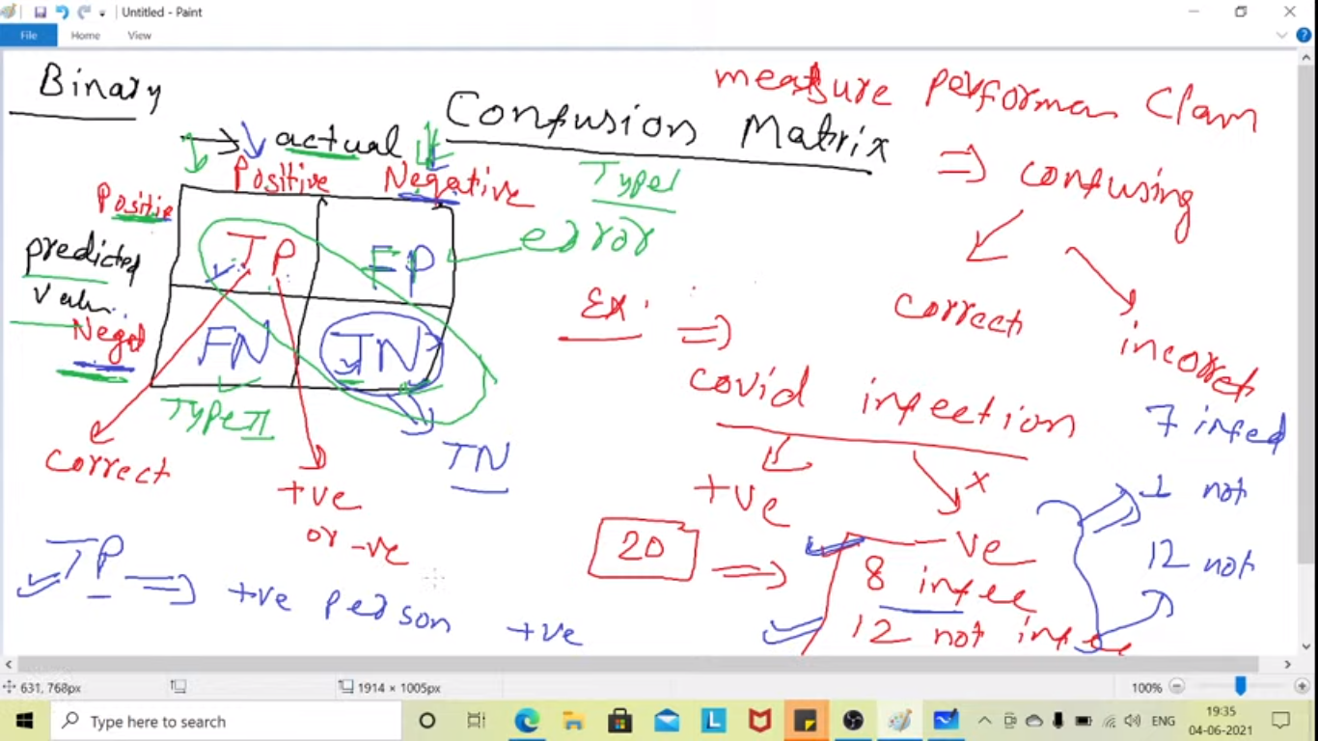

**FP and FN is error**

**Person is Negative the model gives the positive it is FP which is Type 1 error**

**Person is Positive the model gives the negative it is FN which is Type 2 error**

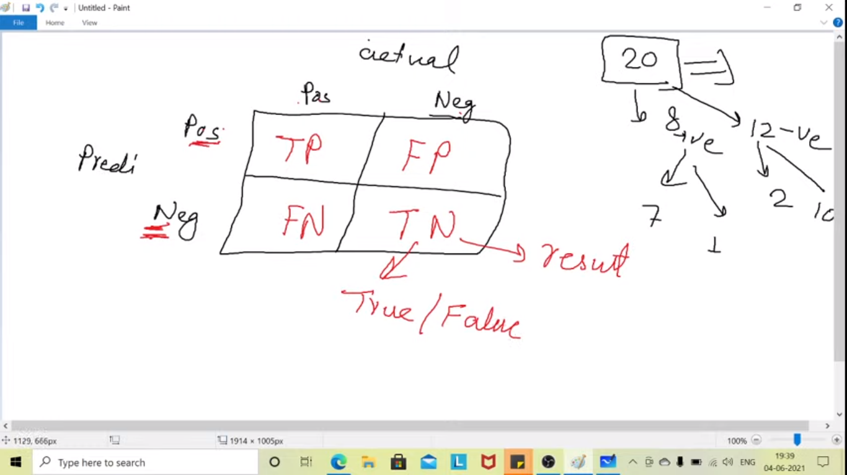

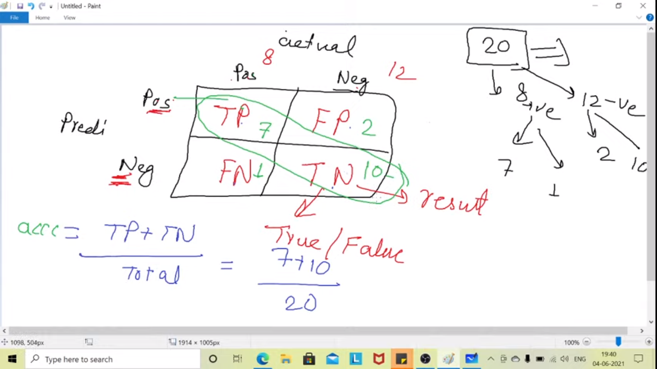

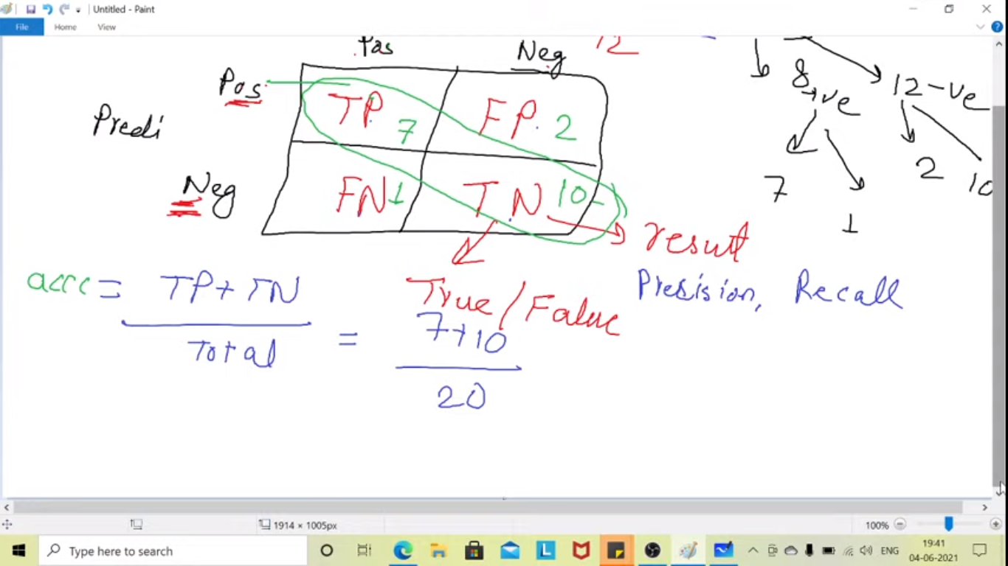

**How many total +ve classes are predicted i.e TP+FP**

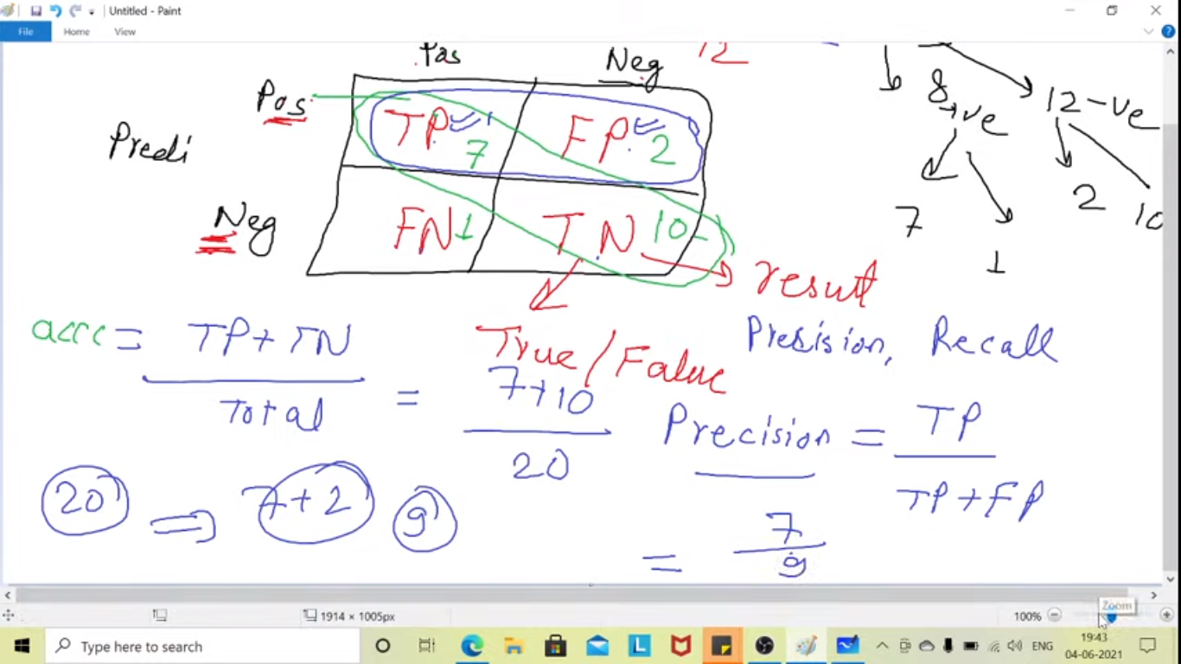

**Precision value has to be 1**

**Recall- actual positive**

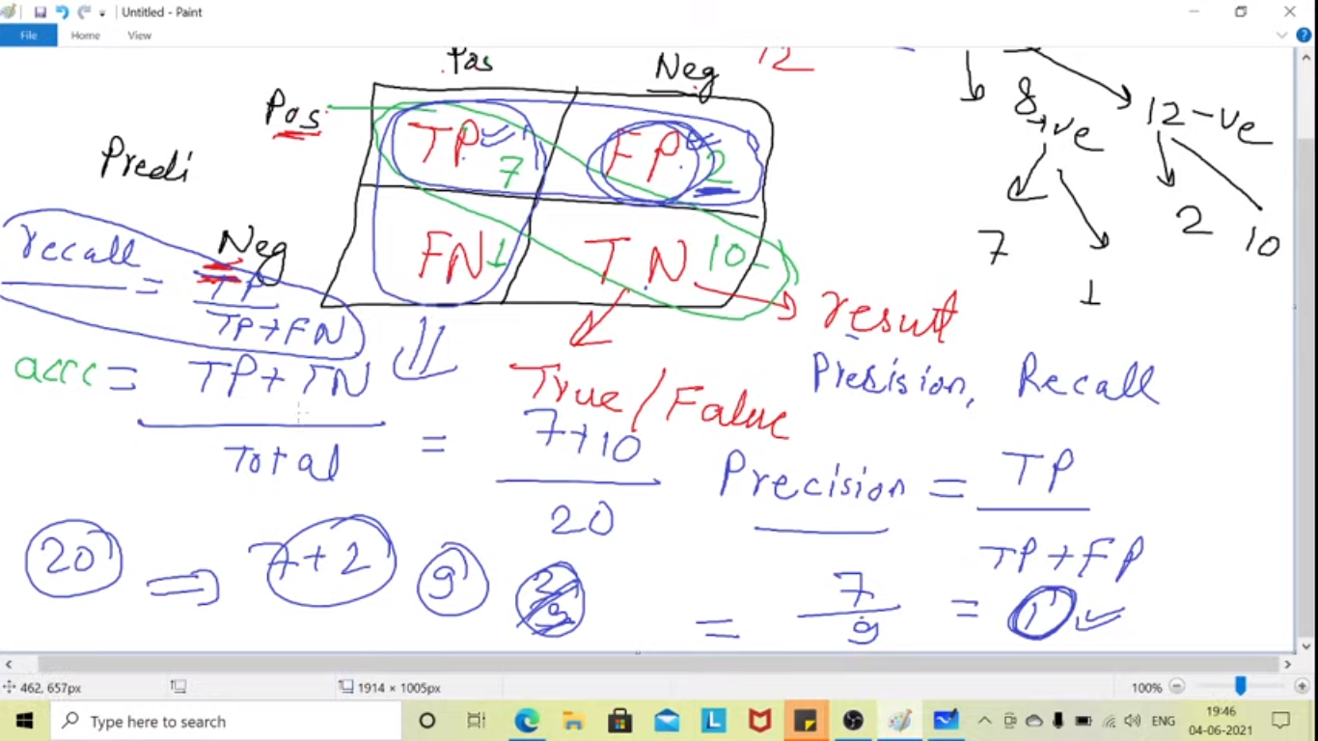

**Recall = TP/(TP+FN)**

**---**

**F-Score**

**Sensitivity**

